ASSIGNMENT-1 SUBMITTED BY : Maryam Shaikh
GENERARTIVE ARTIFICIAL INTELLIGENCE (GEN-AI)
QUESTION-1 1. Explain the architecture and working of autoencoders, including their key variants such as Sparse,Denoising, and Variational Autoencoders, highlighting their applications.Implement a basic autoencoder,using TensorFlow or PyTorch, and demonstrate its use for dimensionality reduction or data generation.
with a sample dataset.
Answer

Autoencoders are a special type of neural networks that learn to compress data into a compact form and then reconstruct it to closely match the original input. They consist of an:
- Encoder that captures important features by reducing dimensionality.
- Decoder that rebuilds the data from this compressed representation.
The model trains by minimizing reconstruction error using loss functions like Mean Squared Error or Binary Cross-Entropy. These are applied in tasks such as noise removal, error detection and feature extraction where capturing efficient data representations is important.

Architecture of Autoencoder
An autoencoder’s architecture consists of three main components that work together to compress and then reconstruct data which are as follows:

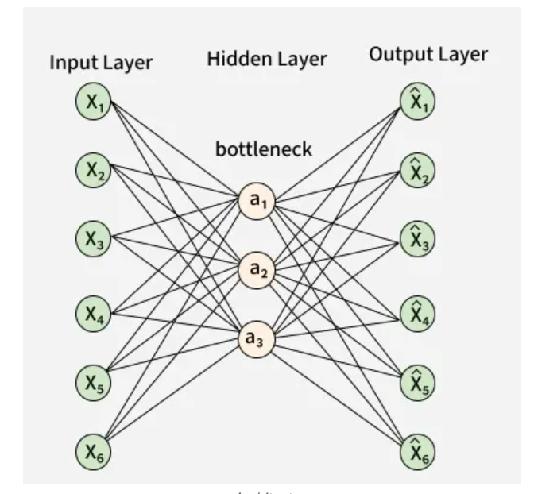

1. Encoder
It compress the input data into a smaller, more manageable form by reducing its dimensionality while preserving important information. It has three layers which are:
- Input Layer: This is where the original data enters the network. It can be images, text features or any other structured data.
- Hidden Layers: These layers perform a series of transformations on the input data. Each hidden layer applies weights and activation functions to capture important patterns, progressively reducing the data's size and complexity.
- Output(Latent Space): The encoder outputs a compressed vector known as the latent representation or encoding. This vector captures the important features of the input data in a condensed form helps in filtering out noise and redundancies.

2. Bottleneck (Latent Space)
It is the smallest layer of the network which represents the most compressed version of the input data. It serves as the information bottleneck which force the network to prioritize the most significant features. This compact representation helps the model learn the underlying structure and key patterns of the input helps in enabling better generalization and efficient data encoding.

3. Decoder
It is responsible for taking the compressed representation from the latent space and reconstructing it back into the original data form.
- Hidden Layers: These layers progressively expand the latent vector back into a higher-dimensional space. Through successive transformations decoder attempts to restore the original data shape and details
- Output Layer: The final layer produces the reconstructed output which aims to closely resemble the original input. The quality of reconstruction depends on how well the encoder-decoder pair can minimize the difference between the input and output during training.

Loss Function in Autoencoder Training
During training an autoencoder’s goal is to minimize the reconstruction loss which measures how different the reconstructed output is from the original input. The choice of loss function depends on the type of data being processed:
- Mean Squared Error (MSE): This is commonly used for continuous data. It measures the average squared differences between the input and the reconstructed data.
- Binary Cross-Entropy: Used for binary data (0 or 1 values). It calculates the difference in probability between the original and reconstructed output.
During training the network updates its weights using backpropagation to minimize this reconstruction loss. By doing this it learns to extract and retain the most important features of the input data which are encoded in the latent space.

Efficient Representations in Autoencoders
Constraining an autoencoder helps it learn meaningful and compact features from the input data which leads to more efficient representations. After training only the encoder part is used to encode similar data for future tasks. Various techniques are used to achieve this are as follows:
- Keep Small Hidden Layers: Limiting the size of each hidden layer forces the network to focus on the most important features. Smaller layers reduce redundancy and allows efficient encoding.
- Regularization: Techniques like L1 or L2 regularization add penalty terms to the loss function. This prevents overfitting by removing excessively large weights which helps in ensuring the model to learns general and useful representations.
- Denoising: In denoising autoencoders random noise is added to the input during training. It learns to remove this noise during reconstruction which helps it focus on core, noise-free features and helps in improving robustness.
- Tuning the Activation Functions: Adjusting activation functions can promote sparsity by activating only a few neurons at a time. This sparsity reduces model complexity and forces the network to capture only the most relevant features.

Types of Autoencoders
Lets see different types of Autoencoders which are designed for specific tasks with unique features:

1. Denoising Autoencoder
Denoising Autoencoder is trained to handle corrupted or noisy inputs, it learns to remove noise and helps in reconstructing clean data. It prevent the network from simply memorizing the input and encourages learning the core features.

2. Sparse Autoencoder
Sparse Autoencoder contains more hidden units than input features but only allows a few neurons to be active simultaneously. This sparsity is controlled by zeroing some hidden units, adjusting activation functions or adding a sparsity penalty to the loss function.

3. Variational Autoencoder
Variational autoencoder (VAE) makes assumptions about the probability distribution of the data and tries to learn a better approximation of it. It uses stochastic gradient descent to optimize and learn the distribution of latent variables. They used for generating new data such as creating realistic images or text.
It assumes that the data is generated by a Directed Graphical Model and tries to learn an approximation to qϕ(z∣x)qϕ​(z∣x) to the conditional property qθ(z∣x)qθ​(z∣x) where ϕ ϕ and θ θ are the parameters of the encoder and the decoder respectively.

4. Convolutional Autoencoder
Convolutional autoencoder uses convolutional neural networks (CNNs) which are designed for processing images. The encoder extracts features using convolutional layers and the decoder reconstructs the image through deconvolution also called as upsampling.

Applications of Auto encoders are:
- Dimensionality Reduction: Compressing high-dimensional data into a lower-dimensional representation for visualization or further processing.
- Feature Extraction: Learning useful and compact features from raw data.
- Anomaly Detection: Identifying data points with high reconstruction errors, indicating they are significantly different from the learned data distribution.
- Image Compression and Denoising: Efficiently compressing images and removing noise.
- Generative Modeling (especially VAEs): Creating new, realistic data samples.

Implementation of Autoencoders
We will create a simple autoencoder with two Dense layers: an encoder that compresses images into a 64-dimensional latent vector and a decoder that reconstructs the original image from this compressed form.
